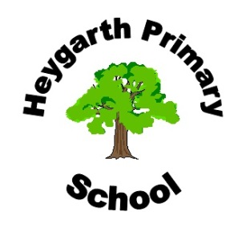

Foundation 1 Overview

Our themes include: All about me and getting along, Autumn and harvest, Bonfire night, Nursery rhymes, Christmas… Other themes will be developed as we follow the children’s interests.

Personal, Social, Emotional Development
New beginnings for our new children and getting to know each other
Making friends and playing together
Following school rules and looking after friends
Tidying up and looking after our resources
Learning to take turns and share
Trying new activities
Healthy lifestyles

Communication and Language
Speaking and listening to each other
Following instructions
Reciting nursery rhymes and songs from memory
Retelling past events
Learning new words and understanding the meaning of them

Physical Development
Riding bikes
Developing spatial awareness
Climbing on outdoor equipment safely
Throwing and catching
Putting on and fastening own coat
Putting on welly boots
Developing a good pencil grip
Developing correct letter formation

Literacy
Nursery children - Letters and sounds phase one (listening and tuning into sounds)
Sharing books and using the reading corner
Handle a book with care
Listen to short stories in a small group
Know the difference between writing and pictures
Develop pencil grip – tripod grip

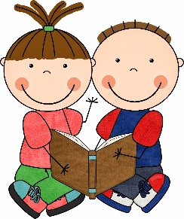

Numeracy
Number recognition and formation
Number songs and rhymes
Counting forwards and backwards
Being aware of time – morning, lunch time, evening…
Counting objects accurately to 5 and beyond
Reading numbers
Talk about every day shapes

Expressive Art and Design
Self portraits
Autumn craft
Learning to paint and mix colours
Exploring instruments
Taking part in role play and small world play
Dancing and singing

Understanding the World
Autumn and Harvest
Fruit and vegetables
Cooking
Similarities and differences between ourselves.
Changes – the weather, the seasons
Introduction to Forest School and how to stay safe
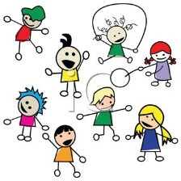
Using a range of computer programs and programmable toys

