Heygarth Primary School

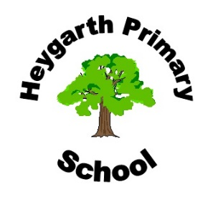
Business Contact Form

COMPANY INFORMATION
Your name:
Company/Business name:
Address:
Telephone number:
Email address:
Website:
Social Media links:
Brief Description of your services:
Company logo (preferably JPEG):

*By submitting this form, I/We accept that this information will be freely accessible on the Heygarth Primary School Website. Heygarth Primary School accept no liability for reproducing information supplied in error. Heygarth Primary School do not actively endorse products or businesses we simply offer parents the opportunity to publicise their business to the wider community. Heygarth Primary School retains overall editorial rights and may choose to remove content at any time without prior notification.

Name: ______________________________

Signature: ______________________________

Date: ______________

